

**WEYBAY NEWS**

A monthly what’s on

**October 2025**

For the fruits of all creation, thanks be to God;

For the gifts of every nation, thanks be to God.

For the ploughing, sowing, reaping,

Silent growth while we are sleeping,

Future needs in earth’s safe-keeping,

Thanks be to God.

Weymouth Bay is part of the Dorset South and West Circuit

**Minister**

Revd Helen Harrell

**Circuit Administrators**

Maria Jacobson 07570 036288

Jacqui Trent 07709601567

Wey Bay Booking Secretary  weybay@yahoo.com 01305457510

Web Circuit address: www.dsw.church

Facebook: Facebook@weybaychurch

Weymouth Bay Methodist Church, 32 Melcombe Avenue, DT4 7TH

Contact the newsletter production team for entries in future newsletters.

Ailsa Binnie binnie148@btinternet.com

Jean Capp jean@thecapps.co.uk

Jackie Chevis [jackietweymouth@yahoo.com](mailto:jackietweymouth@yahoo.com)

**Minister’s Message**

Hi,

I’m Helen and I’m the new circuit minister whom you share with Chickerell, Lanehouse and Easton (Portland) churches. I thought I would use this first letter as an opportunity to introduce myself.

I grew up in London, where I attended the Sunday School and uniformed organisations at the local Baptist church. I made a firm commitment to follow Jesus at a Youth for Christ event when I was 18 years old and was directed to the Methodist Church, where there was a strong youth fellowship. I was very quickly asked to become a Sunday School teacher, and after giving a talk at a youth service, a minister in the circuit suggested that I explore a call to preach. This was put on hold for a couple of years, but in 1990 I was accredited as a local preacher, just before leaving London, where I had been employed in the shipping industry, to go to Cliff College in Derbyshire. On leaving Cliff College, I settled in the Midlands and found work helping those leaving the mining industry to find alternative work or training at the time of the pit closures.

In 1994 I was accepted to train for ordained ministry by the Methodist Church and I went to study at the Wesley Study Centre in Durham. My final year of training was spent in Germany on the MA exchange program between Durham and Tübingen Universities. The first 20 years of my ministry were served in circuits in Yorkshire and then for the past seven years, I have been based in the West Midlands, so it is quite a shock coming so far south.

My passions in ministry are working with children and young people. I have been a school governor and led collective worship, taken “Open the Book” into schools, led Youth Alpha courses and volunteered at 3Generate. I also have an interest in the Global Church, particularly in Europe and Germany and served on the Theological Commission of the European Methodist Council for many years, as well as attending events such as the European Methodist Festival, the Kirchentag and one year I was a delegate to the Conference of European Churches. My Christian faith motivates my desire for social justice – I am a keen supporter of FairTrade, Christian Aid and am actively involved in the Trades Union movement as Vice-chair of the Faith Workers Branch of Unite the Union.

I come from a family of Arsenal supporters. In recent years I have got behind the women’s game and am now a season ticket holder at the Emirates for the WSL matches. Whilst I have never played football myself, I like to keep fit – I swim, do various exercise classes at the leisure centre and participate in parkrun. I also enjoying singing with a choir and I am an avid knitter. I’m also a really bad violinist!

I look forward to getting to know you and working together with you.

Every blessing

Helen

**OUR CIRCUIT**

A joyful service was held at United Church Dorchester at the end of August to welcome our new minister Revd Helen Harrell and to celebrate the churches joining us from the Yeovil and Blackmore Vale Methodist Circuit. The Dorset South and West Circuit has now increased from 12 churches to 18. There is lots of information about the churches that have joined us on the Circuit website. Please have a look at it. This is a large Circuit with a comparatively small ministry team and we hold everyone involved in our prayers.

**PREACHERS AT WEYMOUTH BAY for the coming weeks**:

5th October Colin Farrant

12th October Rev Helen Harrell

Harvest Festival HC

19th October 10.30 am Flora Waring

6.30 pm Rev Jane Wilson

26th October Daniel England

2nd November Rev John Yarrien

**HARVEST FESTIVAL**

Please bring your gifts of produce for harvest festival to the service on 12th October. These will be given to the Weymouth foodbank. After the service you are invited to stay for a lunch of roast beef, Yorkshire pudding and veg followed by apple crumble and custard. The cost of this is £10. Please sign up on the sheet on the notice board to secure your place.

**FAMILY NEWS**

We were sorry to learn of the death of Norman Kember at the beginning of September**,** only 22 days after the death of his dear wife Pat. Norman and Pat attended WeyBay regularly and Norman continued to attend whenever possible after Pat became too frail. A service to celebrate Norman’s life was held at Weymouth Crematorium on Friday 26th September and we send loving sympathy to his daughters and all the family.

**COMING EVENTS**

Saturday 18th October 2.30pm – a musical afternoon with our own Miscellany Band. Refreshments will be available during the interval.

No charge but donations to Weymouth Food Bank

Saturday 1st November 7.30pm: Geoff Miller with Dorchester Big Band

Tickets £12 on door or £10 in advance from Pete 01305 812637

(cash please)

**REGULAR EVENTS**

**Coffee Morning** Every Wednesday, 10.00a.m. to 12.00 noon - join us for a warm cuppa, homemade cakes, and great company! You get excellent value for money and a very friendly atmosphere so come along or bring a friend. Stay for a short or a long time, it doesn’t matter, we’d love to see you. It’s all in a good cause too with proceeds going to church funds and the food bank.

**Prayer group -** A short time of prayer in the chapel every Wednesday before the coffee morning. This is a time for you to bring your own anxieties before the Lord and also to pray for the life of our church here at WeyBay and how we can go forward with God.

**Grace Notes singing group** meets every Wednesday at

10.30am. New members always welcome. This is a very informal group with lots of chat and laughter. Come and sing and have some fun*.*

**Cameo**– a fellowship group for women, which meets fortnightly on Wednesdays from 2.00p.m. to 3.15p.m.

Our meetings for October are:

1st October – the Battle of Weymouth. Hear from Anthony Moore about the time the residents of Weymouth and Wyke were at each other’s throats.

15th October – Athelhampton House, a member of staff tells us about changes and improvements to the house.

29th October – Rachel Rogers explains what services the Citizens Advice Bureau offers.

**Miscellany,** the music group meets in the church every Wednesday from 5-6 pm and is now preparing for the concert later this month. This is for anyone who plays a musical instrument, however brilliant or rusty you may be. You would be very welcome. If you are interested speak to Rosemary or Ailsa for further information.

**Bible Study Group**

Meets on Thursday afternoons at 2pm. This is a very informal group with lots of opportunity for discussion. At present we are looking at the lectionary readings for each week and we welcome anyone who would like to join us.

**Dementia Cafe:**

The next drop in cafe for people with dementia and their carers is on Friday 3rd October. An afternoon of fun with activities, music and of course cake.

More details from Esme on 01305 812637

**Board games afternoon**.

Our monthly board games afternoons will resume this month. The first is on Saturday 25th October from 3pm to 5pm.

Come along and enjoy this fun afternoon for just £2 with light refreshments included. Why not invite a friend to come with you.

The following dates are 15th November and 13th December and

you are reminded that the correct change would be much appreciated.

**Garden Gang**

The next gardening working party will be on Saturday 25th October from 9am to noon. If you would like to help maintain our grounds, please feel free to come and join in. All help gratefully received, you don’t have to come for the whole time. There will be tea, coffee, cake and of course great company.

**Presentation to Food Bank**

A cheque for £492.50 was presented to representatives from Weymouth Foodbank after the coffee morning on Wednesday 3rd September. The money was raised from the sale of bric-a-brac at our Arts and Crafts week and a cheque for the same amount has been given to the Lantern Trust.

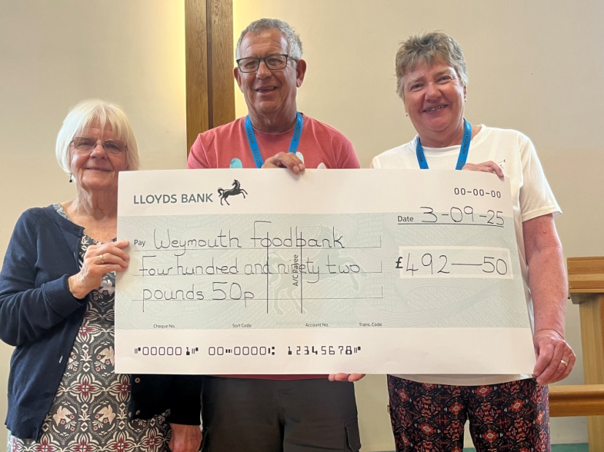

**Supermarket Harvest**

Oh what does harvest mean to me?

I neither sow nor reap,

But glean through supermarket shelves

to pluck what’s going cheap.

No mellow fruitfulness is here

But sterile tidy tins,

And crops all smart in cardboard coats

And glossy plastic skins.

No sound of tractors in the fields

But cram full trolleys clash,

And jingling tills bind sheaves of notes

And gather in the cash.

No need to plough and scatter now

The good seed on the ground.

With canned, convenient, frozen food

It’s harvest all year round.

So through these claustrophobic fields

Robot like I roam

And long for fragrant country air

And joys of harvest home.

So through that soulless check-out point,

Bring all you can afford

And check in here at Weymouth Bay

And come and praise the Lord.

Arnold Kellett (selected verses)

,