


Dorset South & West Circuit

The Methodist Chapel
Tolpuddle
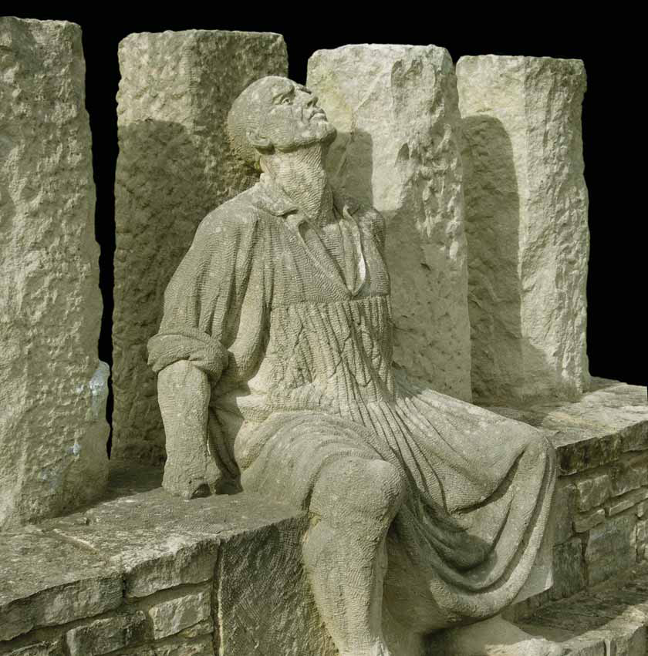
Sunday 20 July 2025
at 5 pm
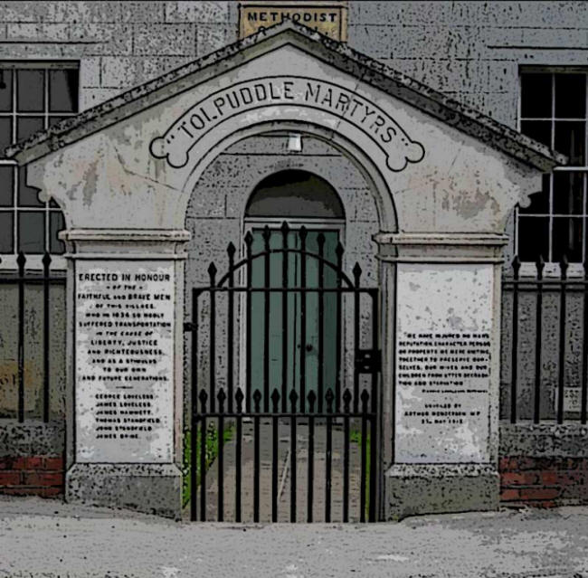
with the President & Vice-President of the Methodist Conference 2025/6
Revd Richard Andrew & Matthew Forsyth

