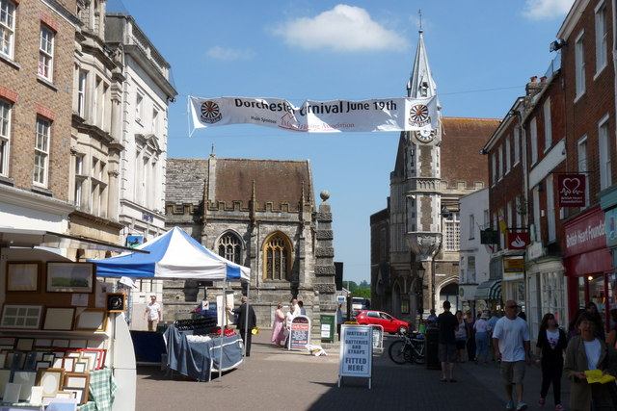
DORCHESTER CHAPLAINCY TEAM

We want to recruit more chaplains to our Dorchester Team..
Dorchester Town Chaplaincy team offers support and encouragement for shop workers, market traders, shoppers and anybody working in the town of Dorchester. We recognise everyone involved in providing a retail service in our town, in whatever capacity, is an individual of value, and like anyone else benefits from a smile and a friendly word of encouragement. Chaplains are experienced listeners, taking an interest in the pressures people may be under. They retain confidentiality where necessary and appropriate.

Who are the Chaplains?
The team is drawn from members of local churches. Each week chaplains visit the town centre. It is an initiative of Churches Together in Dorchester, backed by Dorchester BID and Dorchester Town Council.

What does a chaplain do?
A chaplain does not provide a formal counselling service, but is there to listen and take an interest. Often chaplains will just snatch a few words with people they visit; a means of support and encouragement during the busy working day. They can, if needed, make themselves available for longer conversations over coffee. Although a chaplain is a person of faith, they are not just available to talk about religion, but to listen to whatever people want to talk about. They are interested in people as individuals of value and worth; and what people choose to talk about is entirely up to them!

Why not seriously consider being a chaplain?
It is an important role and many people say how much they value and look forward to chaplains’ visits on a regular basis.
Why not come along to a training session and see if you would like to become a chaplain.
For more details please go to dorchester-chaplains.org.uk

