methodist logo

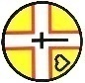**Dorset South & West Circuit**

**The Methodist Chapel**

**Tolpuddle**

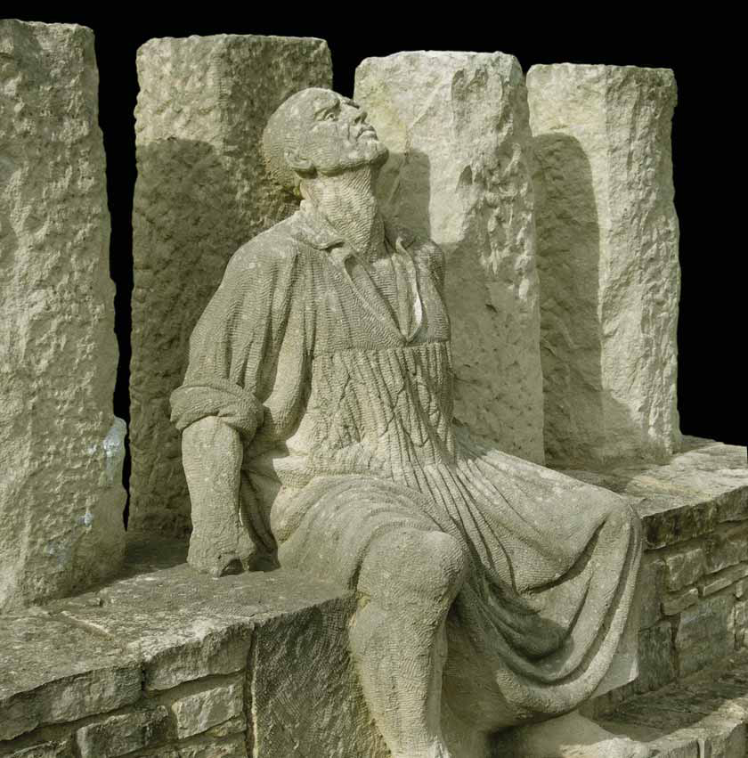

**Sunday 20 July 2025**

**at 5 pm**

**with the President & Vice-President of the Methodist Conference 2025/6**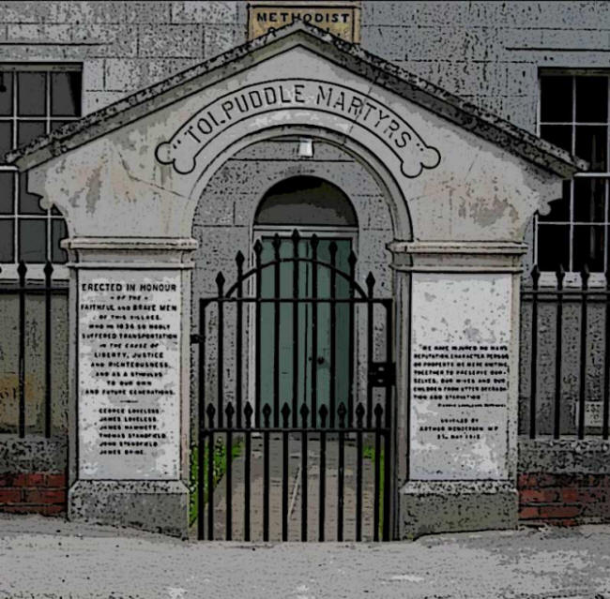

**Revd Richard Andrew & Matthew Forsyth**