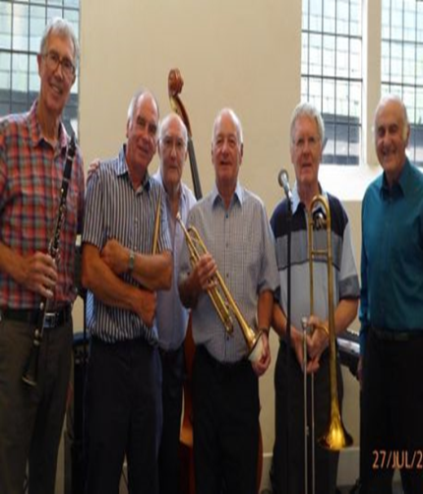
Memphis Jazzmen

Saturday
27th January 2024
at 7.30p.m.

Weymouth Bay Methodist Church
32 Melcombe Avenue DT4 7TH

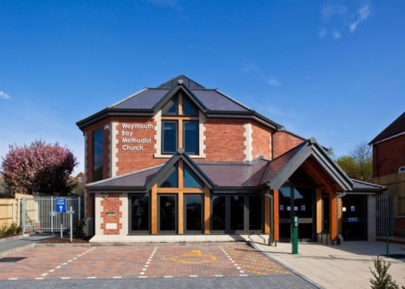
Tickets
£10 in advance or
£12 on the door
Advance tickets from Pete or ring 01305812637

