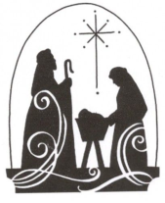
Carol Service
at Weymouth Bay
Methodist Church

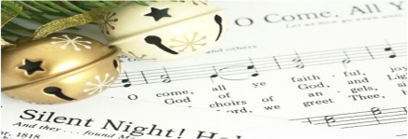
Sunday
17th December 2023

We would love you to join us at 4.30p.m. for tea, sandwiches and cake or
just come to the Carol Service which will start at 6.30p.m.

32 Melcombe Avenue, Weymouth DT4 7TH

