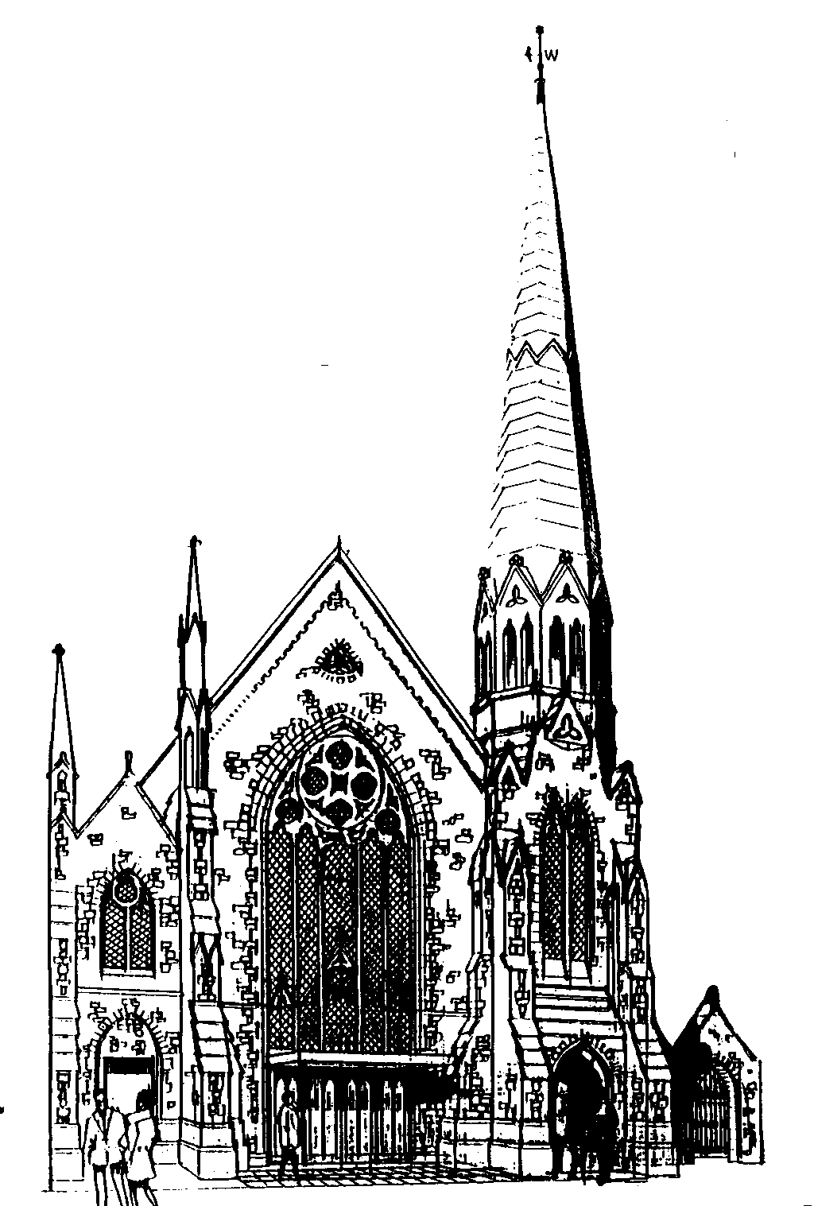
Methodist and United Reformed
Part of Churches Together in Dorchester

Minister:
Rev Peter Clark 01308 425978
Please contact one of the Church Stewards if necessary

Pastoral Visitor: Angela Fisher: 01305 267809
Mobile: 07770 786668
Church Secretary: John Hilton: 01305 267098
jandwehilton@waitrose.com
Senior Steward: John Parson: 01305 561622
jsparson@hotmail.com
Church (general number): 01305 262462
Church office: 01305 457477
Website: unitedchurchdorchester.org.uk

MAY 2020
Registered Charity No: 1137996
Dear Members of UCD,

We now know that lock-down will continue for at least several more weeks. We also expect that the lifting of restrictions will be phased, with some restrictions being lifted earlier than others, so it is likely to be several months before church life can return completely to normal, although we hope that we shall be able to worship in church again before too long.

We live in Brewery Square, and our building (Barley Building) along with Copper Crescent, Keg Store, The Cooperage and Hop House, encircle a garden, and at 6pm each day we all gather at our windows or on our balconies and wave to each other, just to show that we are still alive and kicking. One evening we had a sing-song: “There’s a Hole in my Bucket”; She’ll be coming round the Mountain” etc. When we wave, I always feel sorry for those who live on their own, for whom this may be the only human contact they have all day, and I know that many of you are in the same situation. Please keep in touch with each other by email or, even better, by telephone. Not that being a couple is always sweetness and light. I know that I have annoyed my wife, Enid, on one or two occasions. (Only one or two? Alright, several occasions.)

Many years ago, a minister told of visiting an aged member of his congregation. As he left, he said, “God bless you”, and the old man replied, “He does, and I let Him”. May we all let God bless us with his steadfast love both now at this difficult time and for evermore.

With my best wishes,
John Parson (Senior Steward)

Lectionary readings

3rd May
Acts 2:42-47
Psalm 23
1 Peter 2:19-25
John 10:1-10

10th May
Acts 7:55-60
Psalm 31:1-5, 15-16
1 Peter 2:2-10
John 14:1-14

17th May
Acts 17:22-31
Psalm 66:8-20
1 Peter 3:13-22
John 14:15-21

24th May
Acts 1:6-14
Psalm 68:1-10, 32-35
1 Peter 4:12-14; 5:6-11
John 17:1-11

31st May
Acts 2:1-21 or Numbers 11:24-30
Psalm 104:24-34, 35b
1 Corinthians 12:3b-13 or Acts 2:1-21
John 20:19-23 or John 7:37-39

Church Family News
We give thanks for the life of Deirdre Tapply who died in April and remember her family and friends in our prayers.

Everyday Prayer
For the coming of spring, the warmth of the sun and the love of friends and family we thank you, Lord. In this time of isolation and anxiety we remember all those who are ill and bereaved, and all workers in our hospitals, care homes and hospices. Hold us all in your loving presence, strengthen us and give us hope for the future. Amen

‘When it was evening on that day, the first day of the week, and the doors of the house where the disciples had met were locked for fear..‘ (John 20:19a)

Well as I write this the lockdown continues and we continue to seek to offer church in a different way. In recent phone calls, emails and even cards sent to me I hear that generally, despite the strangeness, we are adapting well and most folk are managing well, or as well as can be reasonably expected? Which is reassuring, especially as I heard a lady in the supermarket in the first week saying something along the lines of “My mother used to say this generation would not have survived the war. I think she’s right and I’m glad she’s not here to see it.”

Now, I am aware that my whole personality is optimistic by nature and I spend my life trying to see the good side of everything, but you know, three weeks on I hope she’s revised her opinion as it seems to me that people have adapted and are surviving remarkably well. More than that, actually as there have been some really excellent examples of people supporting others with phone calls, shopping etc. not to mention prayer support and the regular provision of church services either in hard copy or the rather richer range available online. People have pulled together and have managed with amazing good humour and resourcefulness.

As I cycled up one road, delivering services, I passed through a socially-distanced street party! Outside three houses on one side of the road and another three on the other, couples were sitting on deck chairs on the pavement and having drinks and conversation with their neighbours, folk that I guess they possibly only were on nodding acquaintance with before? I hope and trust that they found out more about each other and firmer friendships were founded on that day - something that might well not have happened but for this horrible pandemic.

And it is horrible and it is threatening and it is something riven with tragedy and sadness as thousands suffer illness, death and loss. But in the midst of it all there is a resilience and a lot of positive vibes and I wonder if in years to come folk will talk of the ‘Covid-19’ Spirit in the way we talk of the resilience of the WWII struggles?

And one more thing. When I was leaving my last pastorate, I lifted a corn dolly off the wall in my study. I had kept it as a sort of memento from Hartley URC, which had closed its building during my time there. However, as I moved it, the fragile old thing disintegrated in my hands and I have to confess I was a bit saddened by that tiny loss, sharing the story with one of my Elders.

Then, when I was inducted here, that very Elder took part in the service and handed me another memento from that closed church - a carved piece of wood that sits now above the doorway in my study with two words that I regularly notice when I walk out. Two words that remind me that throughout all the turmoil and tragedy, amongst the bright spots too, that we are not alone while all this is going on.

Those two words are “Thou remainest.”

With blessings, love and prayers for you all.
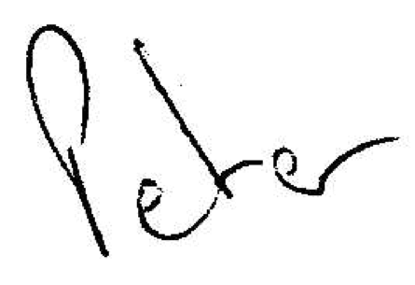
Your Minister,

Support Service
Worried about going out? Finding it hard to cope with queueing? Family too far away to help? Needing to self-isolate?

Please don’t struggle on alone and put yourself at risk. Don’t forget there is a cheerful and willing band of younger folk from church who are very happy to help out. In the weeks prior to Easter we were able to complete 13 batches of shopping and collect and deliver 9 prescriptions. We could easily manage to help more people so if you or folk you know need support then please make contact whenever you need it.
Support is being coordinated by Gill & Peter Robinson.
Tel 01305 266351. Email petergillrobinson@btinternet.com

Thy Kingdom Come
These familiar words from the Lord’s Prayer are also the name of a prayer movement, started less than four years ago by the Archbishops of Canterbury and York, which is now worldwide and ecumenical. It consists of each of us praying for up to five people each day from Ascension Day to Pentecost. Ascension Day, which is the fortieth day after Easter, is this year on Thursday, 21st May. Pentecost is ten days later on Sunday, 31st May, so we are asked to pray on each of eleven days. We pray for up to five people, so it may be for two or three or four. It is recommended that we pray for no more than five, but, of course, our prayers are private and personal, between each of us and God, so the decision is ours.
For whom should we pray? For family and friends, but which ones?
People who regularly attend church but have not yet developed a deep faith in Jesus as their Lord and Saviour.
People who used to have faith and attend church regularly, but have lost their faith and no longer attend.
People who used to have faith and attend church regularly, but, whilst not losing their faith, have been put off the church by something which was said or done by church members, perhaps many years ago. They have fallen out with the church but not fallen out with God.
People who have never had faith and never attended church regularly.
On the day of his ascension, Jesus told his remaining disciples to stay in Jerusalem until the Holy Spirit came upon them. The disciples returned to Jerusalem and, along with Jesus’s mother, Mary, and other followers, they met each day to pray, until the day of Pentecost when the Holy Spirit came in power among them.
In like manner, we pray, “Come, Holy Spirit, Come”, that those for whom we pray may grow in faith and become regular members of a worshipping community.
When copies of “Vision” magazine were given out, we were given cards on which we could each write the names of those for whom we shall pray. Don’t worry if you have lost your card(s), you can write the names on any piece of paper.
You can find out more at https://www.thykingdomcome.global/

Coffee and chat
As part of our continuing efforts to help everyone feel that they are still part of a larger community, we have been investigating how best to create ‘virtual’ or online meetings for groups of church members. Many of us will be used to using things like Skype or Facetime for one-to-one video calls, and we think we’ve found a way of doing something similar but with larger groups.

So we shall be trying out a virtual or online ‘coffee and chat’ session – hopefully three times a week, at 11.00 on Mondays, Wednesdays and Fridays. If you think you might be interested in joining this group (on any of the days), please email coffee.chat@unitedchurchdorchester.org.uk and we’ll send you further details. These details will confirm that you only need very basic computer skills. We will guide you through (either with written instructions or verbally by telephone) exactly what you need to do and you will discover that you have learnt something new at the end, as well as having a good chat, face-to-face, with a group of your friends.

From Sue Chown
Dear all,

As I write this it is raining after so many glorious, sunny weeks, so I hope all you gardeners are up to date with your gardening tasks.

Funny how things come up and knock you over. I have just finished listening to an old recording of Sue McGregor’s programme, “The Reunion”, on Radio 4, and this week it was the three Beirut hostages, Brian Keenan, John McCarthy and Terry Waite with Jill Morell, John’s girlfriend. What a remarkable quartet they are.

I got very involved with Jill’s campaign right from the beginning. I knew Beirut fairly well as my family and I spent some holiday time there each summer when we flew down from Kirkuk in northern Iraq to escape the severe heat, and it was nice to see the sea! Actually the climate there was equally unpleasant with high humidity and awful insects! Beirut was very cosmopolitan as a gateway between west and east, and it gave my Mum the opportunity to see some shops - very few in Kirkuk town! The material for my wedding veil came from Beirut.

Anyway, to get back to the hostages. I couldn’t imagine how any of them survived being chained to radiators for years, and TW was in solitary confinement for more than 4 years. They were transported from place to place bound, gagged, put in sacks in boots of cars through the Bekka valley - just imagine - in that heat or severe cold in winter.

I wrote endless letters to anyone I could think of, made my colleagues in Petersfield Library only drink from “Don’t forget the hostages in Beirut” mugs, and wrote a stern letter to the Times (which was published!) when Saddam Hussein released the British hostages in Kuwait, saying that it was wonderful that those folks were released after a very short time while the Beirut men were still in captivity.

At that time I drove a mustard coloured Mini Clubman, and had yellow ribbons on my radio aerial, probably illegal I expect. On the day that John M was released, I was driving to my job at Uppark and a ribbon blew off, and instead of stopping the car to find it, I drove into the next lay-by and wept.

Stay well all of you.
Love,
Sue
Zoom service
Join members from across the circuit for a weekly Zoom service every Sunday at 10am led by our local ministers and lay preachers. To receive your first Zoom invitation to this service e-mail Rev Gwyneth Owen at owengwyneth@btinternet.com.

Prayer Chain
If you would like prayer for yourself or others at any time, please contact Penny Fennell (01305 267986). Details can be given anonymously, and confidentiality within the prayer chain is absolute unless there is a safeguarding risk.

Marmalade  Oliver is still making marmalade to raise funds for his expedition to Peru. If you would like some, please phone Val on 01305 262746. Delivery or pick-up can be arranged. |  | 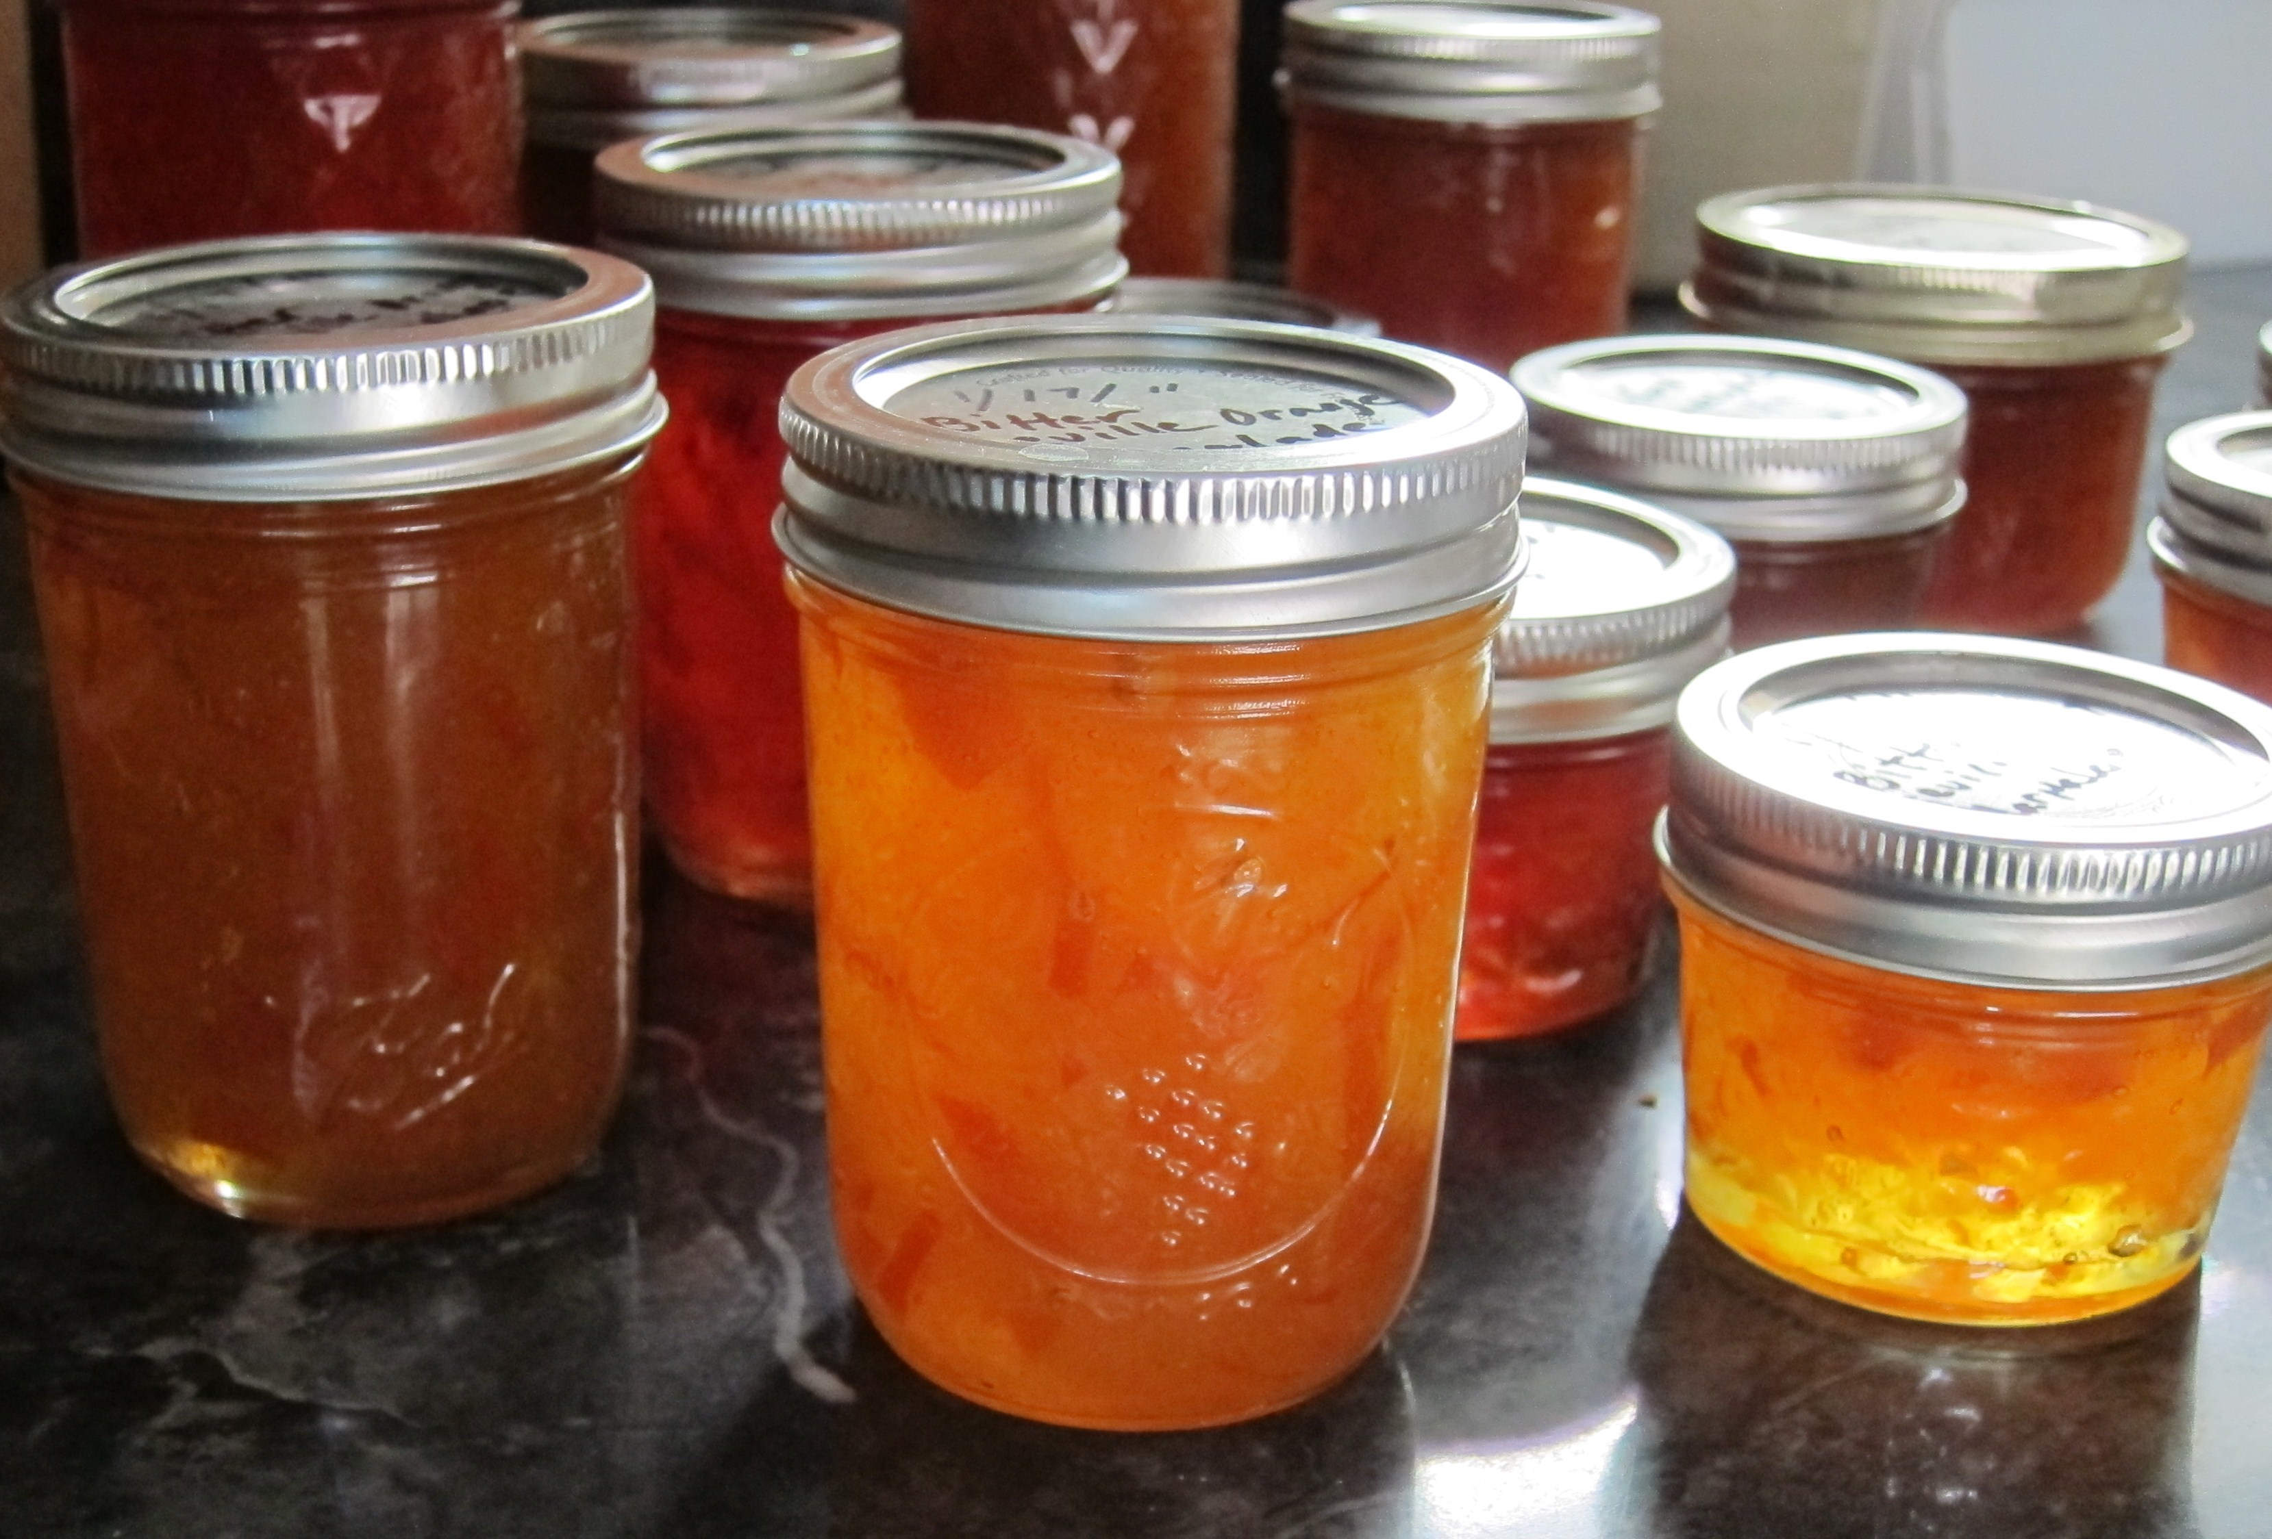

Love Letters during Lockdown
You may have read an article in the Dorset Echo on 9th April featuring two members of our congregation, Ken and Rosemary Mills. The article reports that they are spending their time in isolation reading the love letters that they sent to each other almost 70 years ago, when Ken was away on national service between 1950 and 1952. They have been married for 67 years and are enjoying reminiscing and reliving their youth through their own words. Ken said “It was a holiday romance. We found that we had much in common. We played tennis together and went to church together and we just fell in love.” They each sent two or three letters a week for two years when Ken was stationed in Taunton and Rosemary worked at Harwell Laboratory in Oxfordshire, so there are a lot of letters to get through.

They didn’t have phones so they couldn’t ring each other, and they are saddened that future generations will be unlikely to get to enjoy such a pastime as technology has meant that love letters have become a thing of the past.

Notices for order of service and news sheet
The deadline for the June news sheet is Sunday 24th May. Please send notices for inclusion to Myra Dawson: myradawson2@aol.com.
Church Website
Don’t forget to check out the church website (http://unitedchurchdorchester.org.uk), which is managed by Susy and Kevin Rogers. As well as a downloadable version of the news sheet, it also gives information about the church and its various groups, events, reports and how to contact specific members/groups. The website belongs to the church as a whole so you are encouraged to contribute. Where possible, go, discover and explore!
Data Protection Act
In common with most other churches and organisations, the United Church Dorchester keeps pastoral records of the names, addresses and telephone numbers of regular worshippers and friends. The information is used for church purposes only, is never communicated to any other body and is held in accordance with the Data Protection Act 1998. Please notify us in writing if you do not wish your data to be held by us in this way.

